High-Fidelity Mockup Design Specification
Dwell — Secure Multi-Vendor Product Discovery Platform
Prepared for: Industrial Consulting Project — MVP Development of a Secure Multi-Vendor Product Discovery Platform
Deliverable: Section 1.7 — High-Fidelity Mockups
Prepared by: San
Date: 5 July 2026
Note: this document reflects one member's individual contribution to a group submission and covers the high-fidelity mockup deliverable only.

1. Introduction
This document presents the high-fidelity mockups produced for the Dwell multi-vendor product discovery platform, addressing Section 1.7 of the assessment brief. The mockups convert the group's existing low-fidelity wireframes — the homepage, product listing page, product details page, vendor page, admin dashboard, and combined login/register page — into polished, visually consistent screens, without introducing pages or features beyond those already defined in the project's information architecture.
A consistent visual identity was applied across all screens, built around a mint and forest-green colour palette, a two-typeface system (Poppins for headings, Lato for body text), and a shared set of reusable components (buttons, cards, badges, form fields, and image placeholders). A placeholder wordmark (“LOGO”) was used throughout, as the group had not yet agreed a final brand identity at the time these mockups were produced; the palette and component system are designed to transfer directly onto a final logo once one is selected.
In line with the brief's requirement for both mobile and desktop versions, the three screens that make up the platform's core discovery journey — homepage, product listing, and product details — were completed at both breakpoints. The remaining screens (login/register, vendor profile, and admin dashboard) were completed at the desktop breakpoint only, since these are lower-frequency, task-oriented flows that the group's own persona work characterises as being carried out primarily on a laptop or desktop device; full mobile treatment of these screens is recommended as follow-up work during Phase 2 build.

2. Colour Palette
Green was selected as the platform's core colour because of its strong association with trust, verification and environmental quality — qualities that address the brief's user-research goal of making a multi-vendor platform feel trustworthy. A darker forest-green anchors primary actions and navigation so that calls to action carry enough visual weight against a busy, product-photography-heavy layout, while a lighter mint tone is reserved for lightweight metadata (stock badges, category tags) so that it never competes with product imagery. A single red tone is retained, used exclusively for form validation errors, since usability heuristics call for error states to remain visually distinct from the rest of the interface regardless of the base palette.
Swatch | Role | Hex | Primary usage
 | Forest Green (Primary) | #1B4332 | Navigation bar, primary buttons, headings, footer background
 | Primary Dark | #12281C | Hover / active state for primary elements
 | Mid Green (Secondary) | #2D6A4F | Secondary buttons, links, active navigation state
 | Leaf Green | #40916C | Icons, price emphasis, decorative accents
 | Mint (Accent) | #95D5B2 | Badges, stock tags, highlight chips
 | Pale Mint | #EAF6EF | Hero background, alternating section backgrounds
 | Base Background | #FAFBF9 | Page background
 | White | #FFFFFF | Cards, input fields, header bar
 | Text Primary | #1B2B22 | Headings and body copy
 | Text Muted | #5B6B63 | Secondary / meta text, placeholder copy
 | Border | #D7E6DD | Dividers, input outlines, card borders
 | Error | #BA1A1A | Form validation messaging only

3. Typography
A two-typeface system was used throughout. Poppins, a geometric sans-serif, is used for headings and product titles, giving the platform a modern and approachable brand character. Lato is used for body copy, buttons, and dense interface text (prices, filters, descriptions), as its larger x-height and neutral letterforms keep small text legible — an important consideration given the brief's accessibility requirement for readable font sizes across the platform.
Role | Typeface / weight | Size range
Page and section headings | Poppins, Bold | 20–36 px
Product / card titles | Poppins, SemiBold–Bold | 15–18 px
Body copy | Lato, Regular | 13–16 px
Buttons and labels | Lato, Bold | 12–16 px
Meta / helper text | Lato, Regular | 11–13 px

4. Component Style Guide

4.1 Buttons
Four button styles are used consistently across the platform. Primary buttons (solid forest-green fill, white text) mark the main conversion action on each screen, such as Browse products, Log in, and Save product. Secondary buttons (solid mid-green fill, white text) are used for constructive but non-primary actions, such as Create account and Add product. Outline buttons (white fill, forest-green border and text) are used for lower-emphasis actions such as View and Vendors. A ghost variant (neutral border, dark text) is used for toggle-style controls, such as the Filters and Sort pills on the mobile product listing page.

4.2 Cards, badges, and form fields
A single rounded card component (white fill, light sage border, 14px corner radius) is reused for product cards, category tiles, the filter sidebar, vendor panels, and admin forms, giving the interface a consistent rhythm throughout. Badges are fully rounded pills in mint or pale-mint fill with forest-green text, used for stock status and category tags. Image placeholders use a pale sage fill with a simple picture glyph, standing in for product photography, vendor logos, and category icons ahead of the Phase 2 build. Form fields share one style across the site: white fill, 1px light-sage border, and 8px corner radius, used consistently in the search bar, the filter sidebar, the login/register forms, and the admin add/edit product form.

5. Screen-by-Screen Mockups

5.1 Homepage — Desktop
The homepage combines the hero section, search bar, and featured categories required by the brief (Section 2.3) with a short “Why shop with Dwell” trust panel and a footer linking to the About and Privacy pages defined in the platform's information architecture (Section 1.5). The hero uses the pale-mint surface tint to separate it from the page background while keeping the forest-green heading text at a strong contrast ratio.
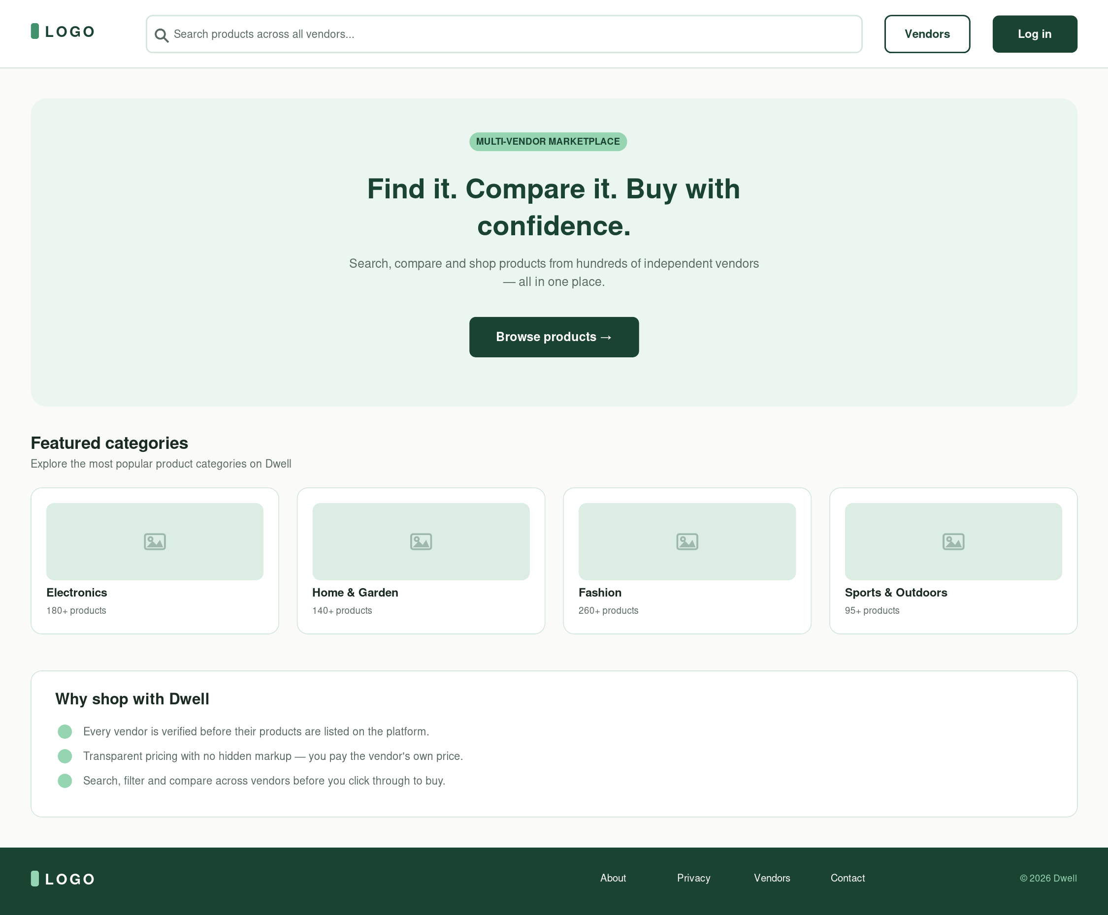
Figure 5.1 — Homepage (Desktop)

5.2 Product Listing Page — Desktop
This screen implements the filter sidebar (category, price range, and vendor, matching the required GET /api/products filters), the sort control (price ascending/descending, newest), and the product grid. Each product card shows the image, title, vendor name, price, and a View action, matching the product card specification in Section 2.3 of the brief exactly.
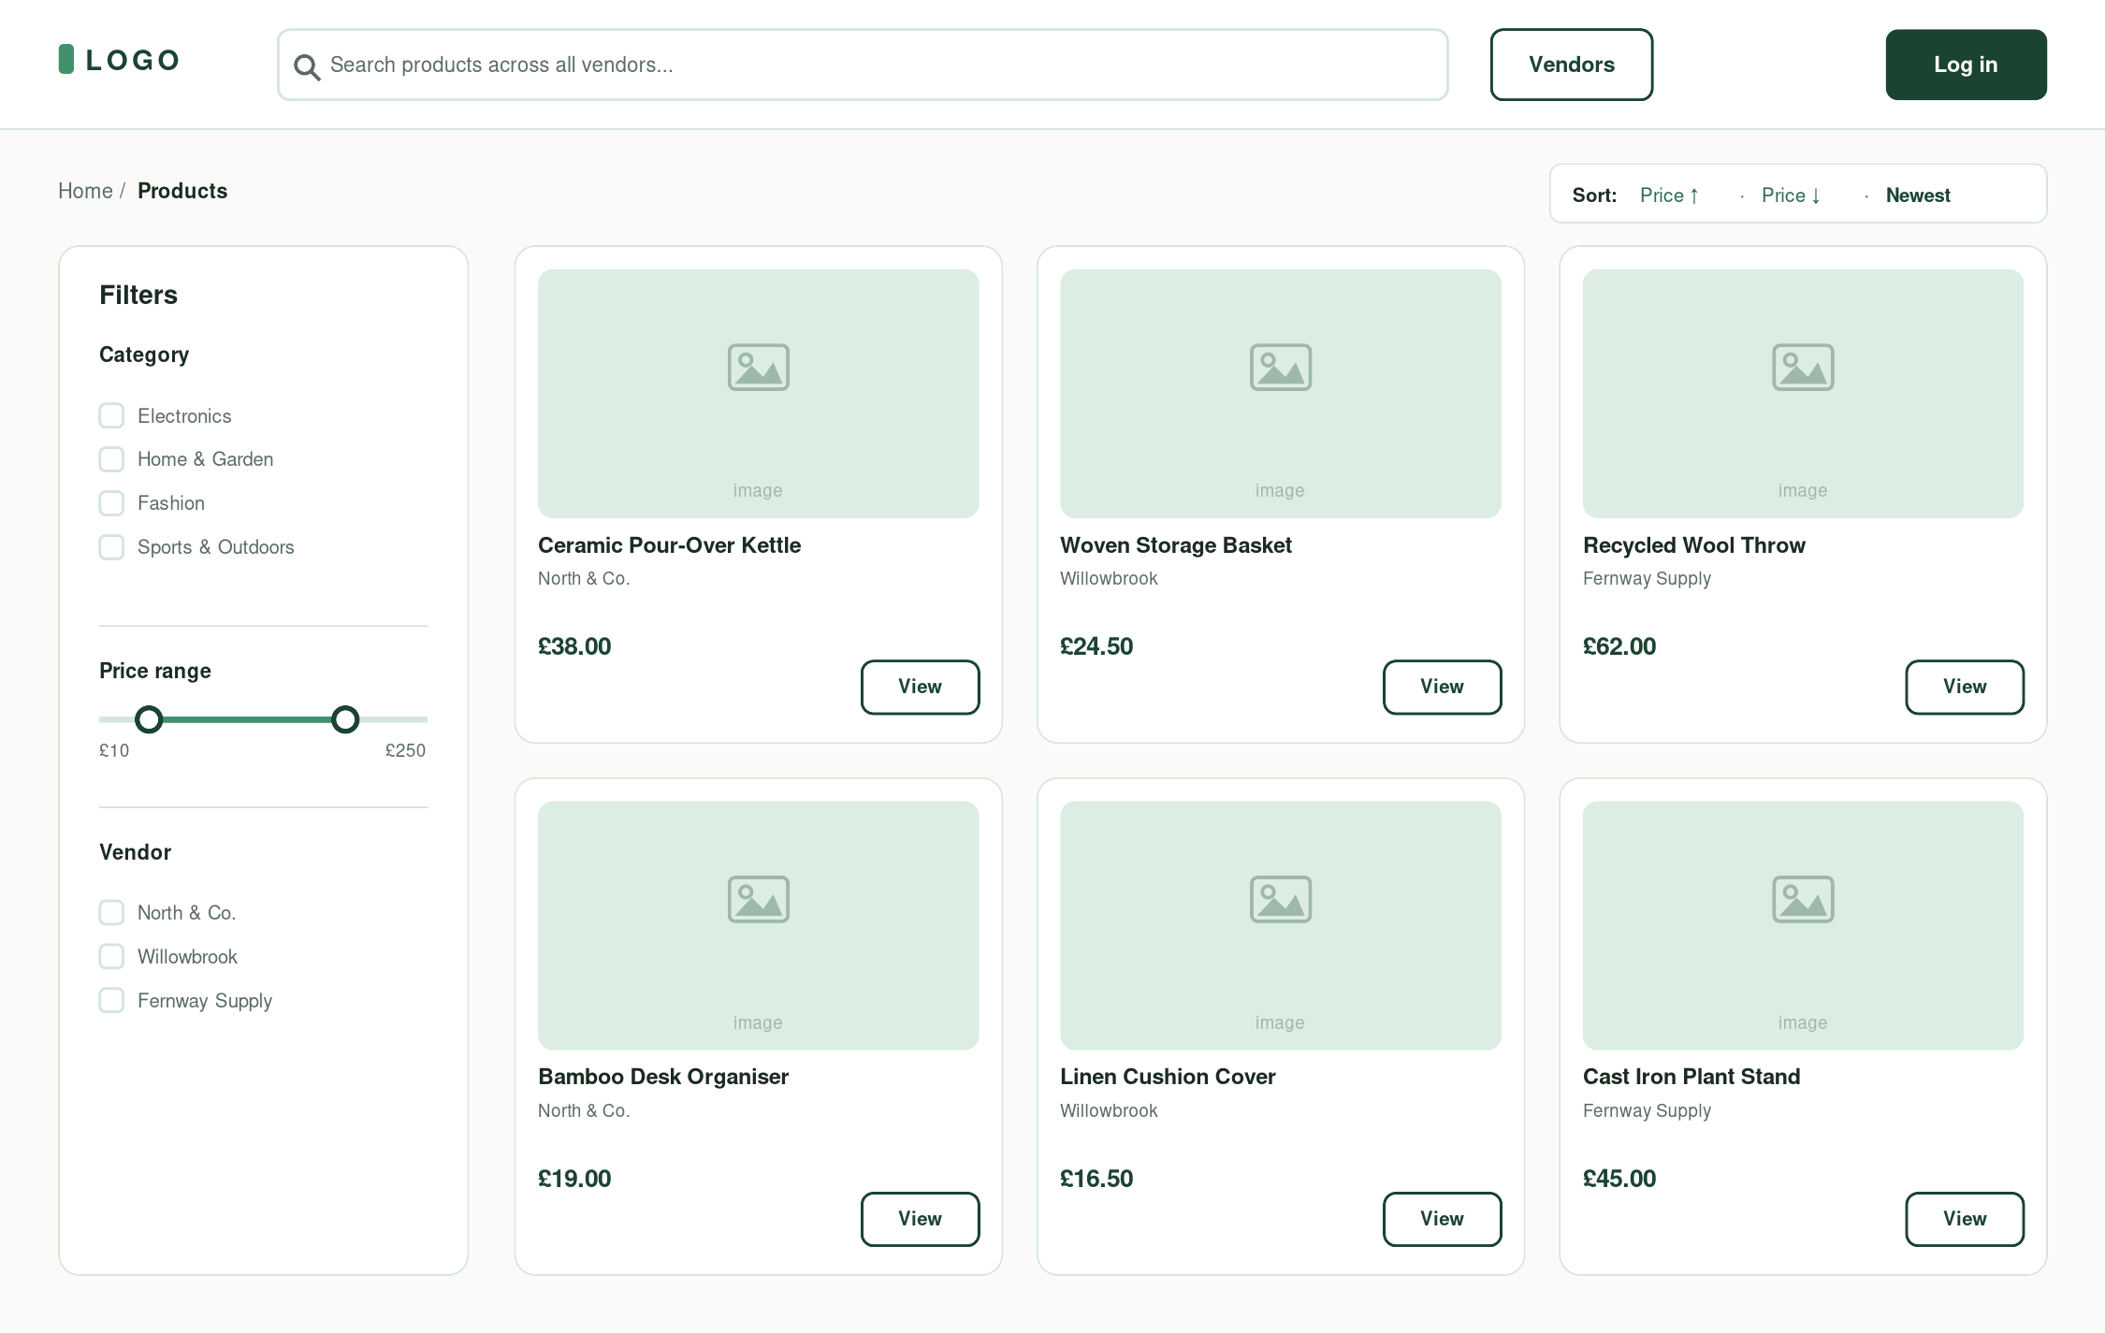
Figure 5.2 — Product Listing (Desktop)

5.3 Product Details Page — Desktop
The product details screen surfaces the category, title, vendor link, price, and stock badge above the fold, followed by a description and two calls to action: Visit vendor website, which represents the external product_url click-through described in the brief's user journey (Section 1.4, step 6), and a secondary Save for later action.
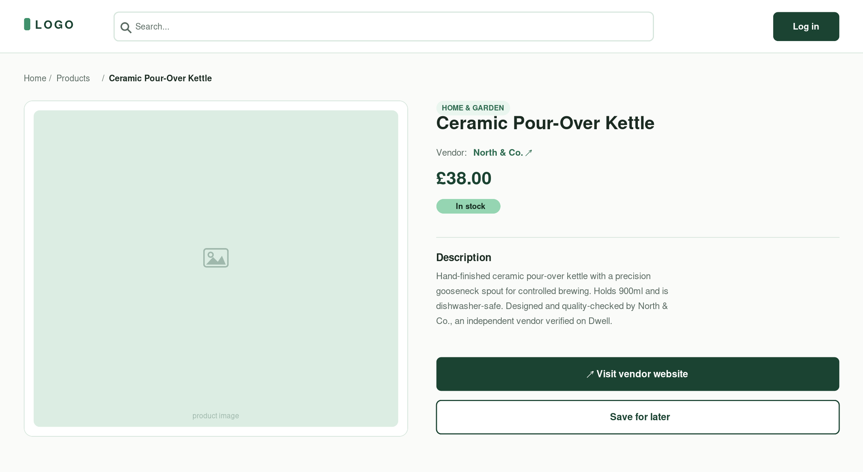
Figure 5.3 — Product Details (Desktop)

5.4 Vendor Page — Desktop
The vendor page presents the vendor profile section required by Section 2.3 (logo, description, verification status, and an outbound Visit website link) together with a grid of that vendor's own products, reusing the same product card component as the listing page for visual consistency.
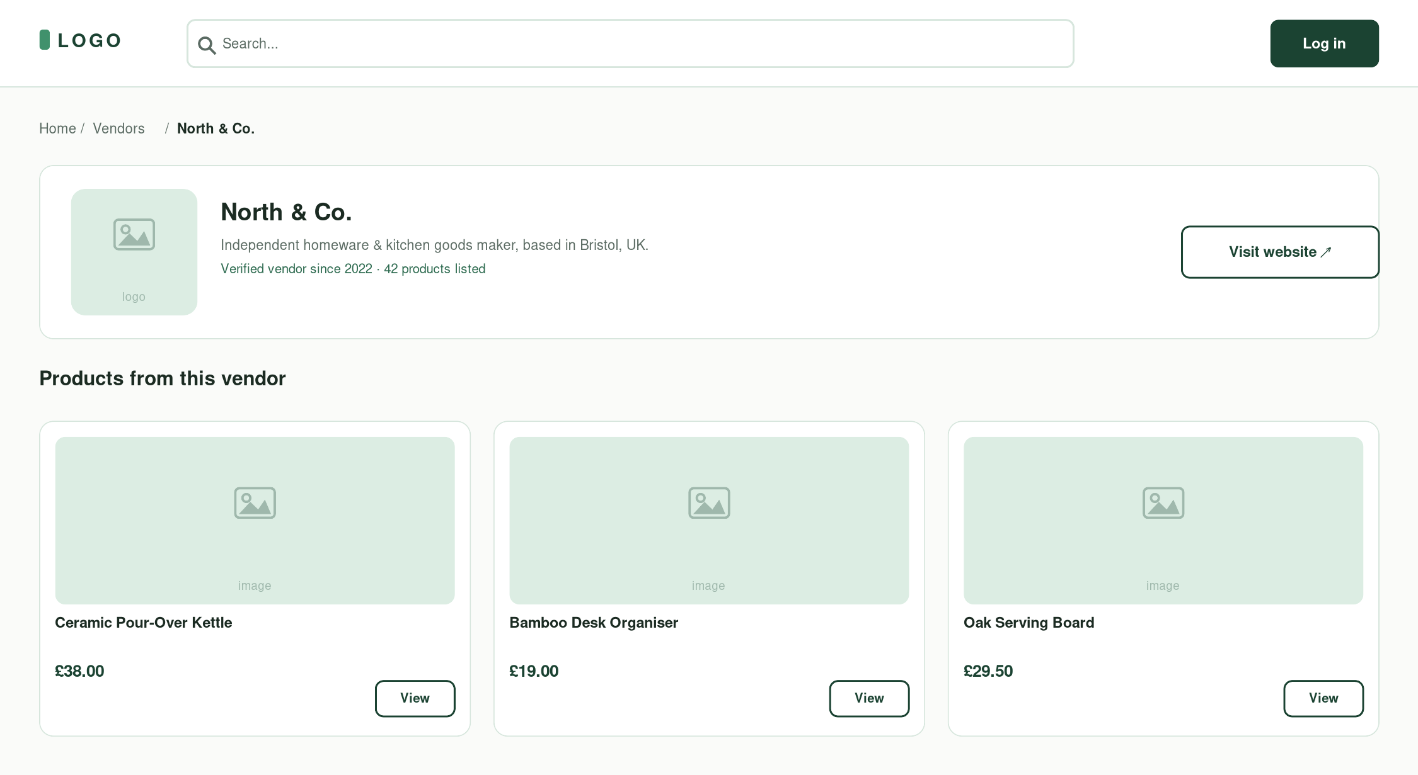
Figure 5.4 — Vendor Page (Desktop)

5.5 Admin Dashboard — Desktop
The admin dashboard combines a product management table (edit/delete actions) with the full add/edit product form. Every field in the form — title, category, price, vendor, image URL, external product URL, description, and availability — corresponds directly to the product schema and dashboard requirements set out in Section 2.6 of the brief, so that this mockup can be used as a literal field-by-field reference during the React build.
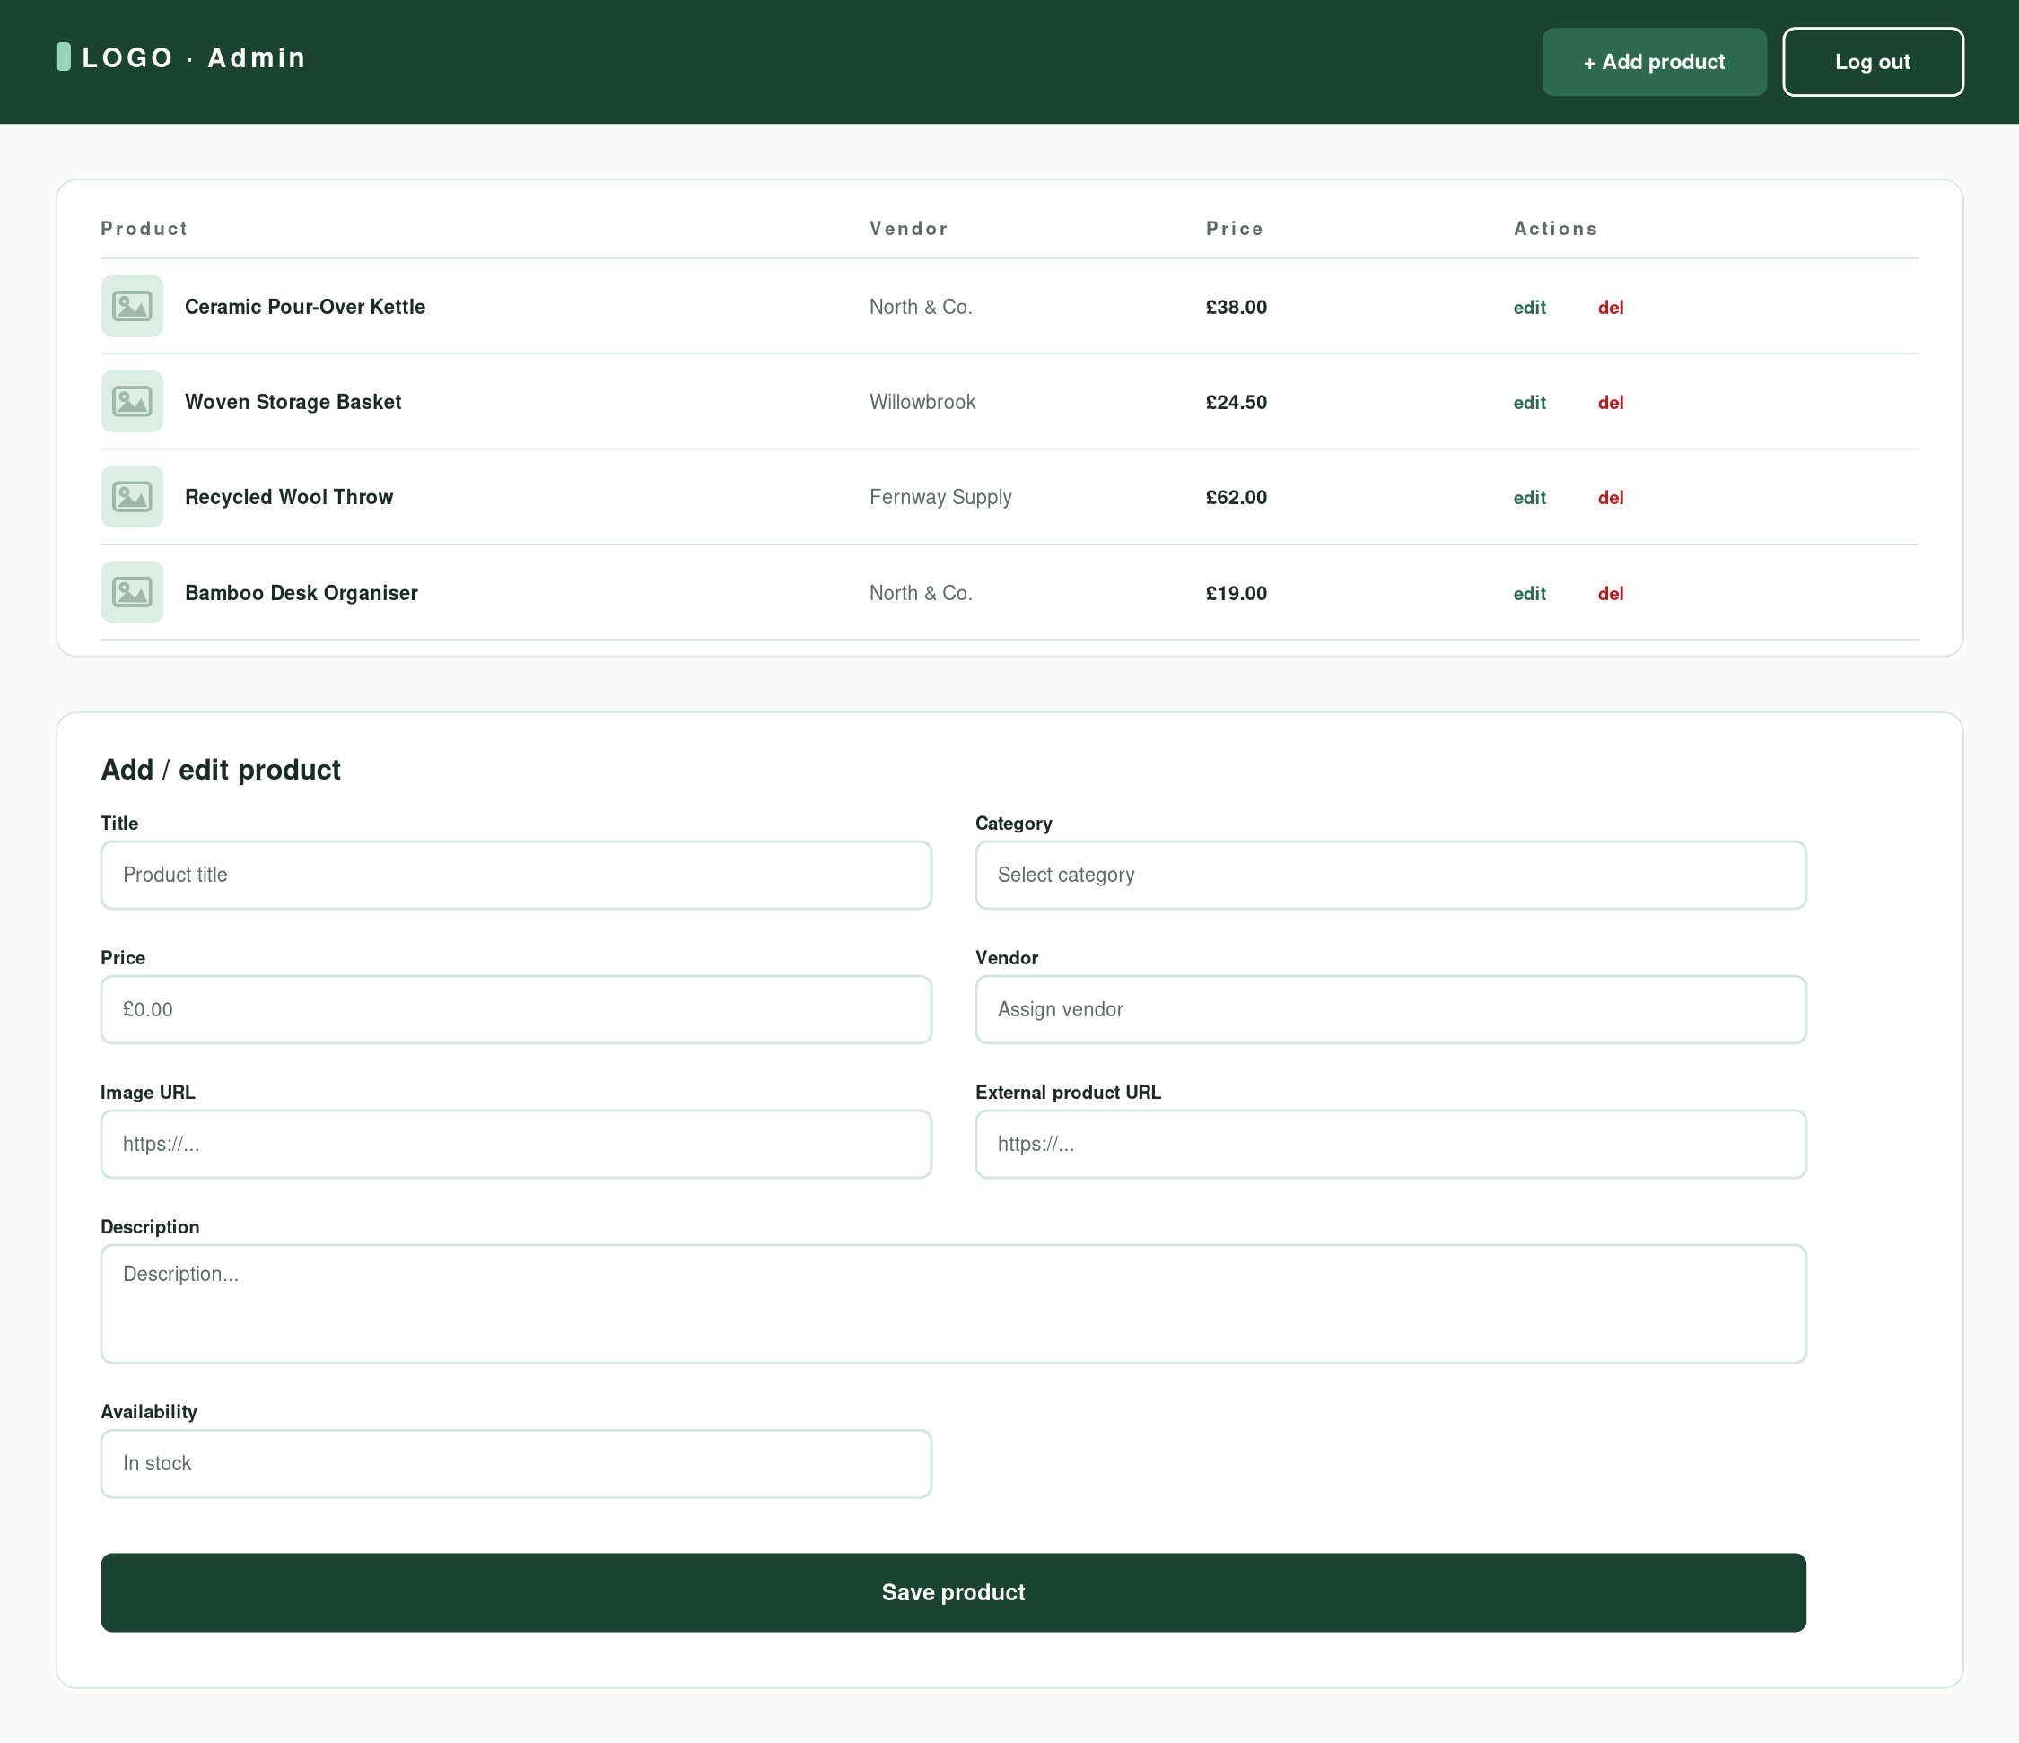
Figure 5.5 — Admin Dashboard (Desktop)

5.6 Login and Register — Desktop
Login and registration are presented as two stacked cards on a single page, matching the group's original wireframe. Password fields are masked, and the primary/secondary button distinction is used to visually separate the two actions (Log in vs. Create account) while keeping both forms within a single, consistent card style.
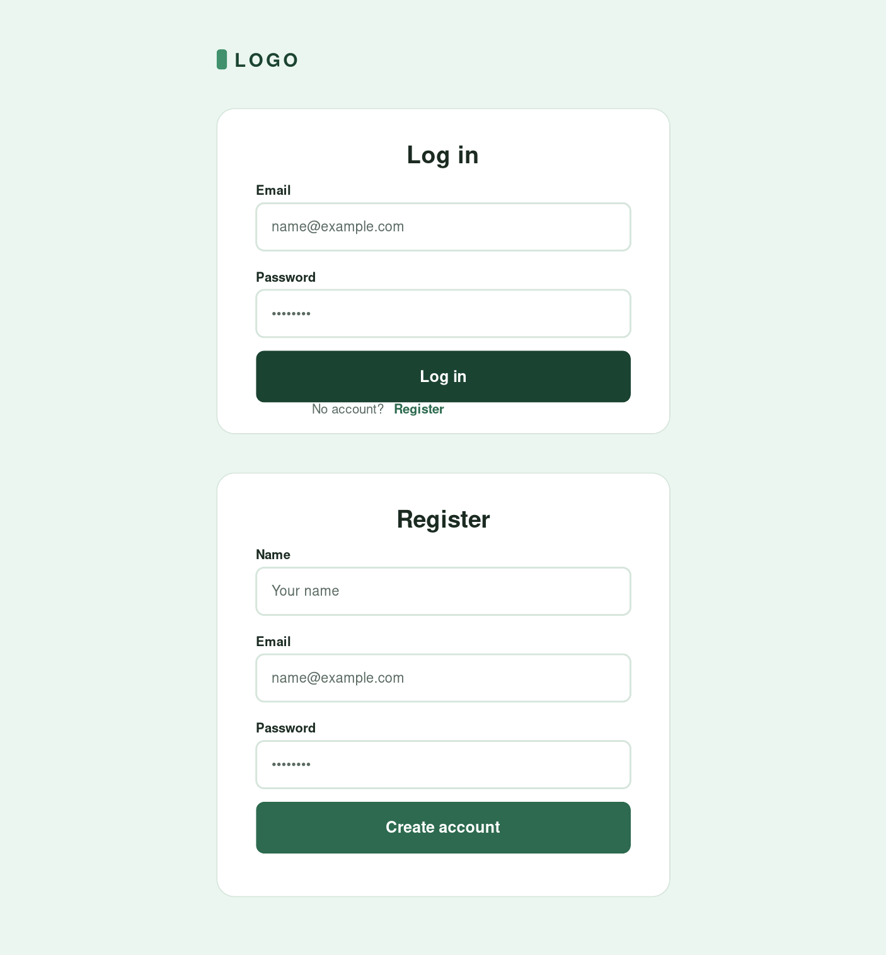
Figure 5.6 — Login / Register (Desktop)

5.7 Homepage — Mobile
On mobile, the navigation collapses to a logo and menu icon, the search bar moves to its own full-width row, and the featured categories reflow from a four-column to a two-column grid, keeping all homepage content accessible within a 375–390px viewport without horizontal scrolling.
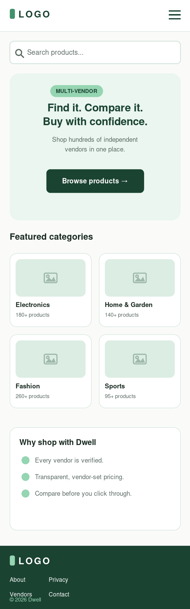
Figure 5.7 — Homepage (Mobile)

5.8 Product Listing — Mobile
The filter sidebar and sort control are replaced with two compact Filters and Sort buttons, intended to open as overlays or bottom sheets in the built application, and the product grid reflows to two columns — directly reflecting the group's mobile wireframe for this screen.
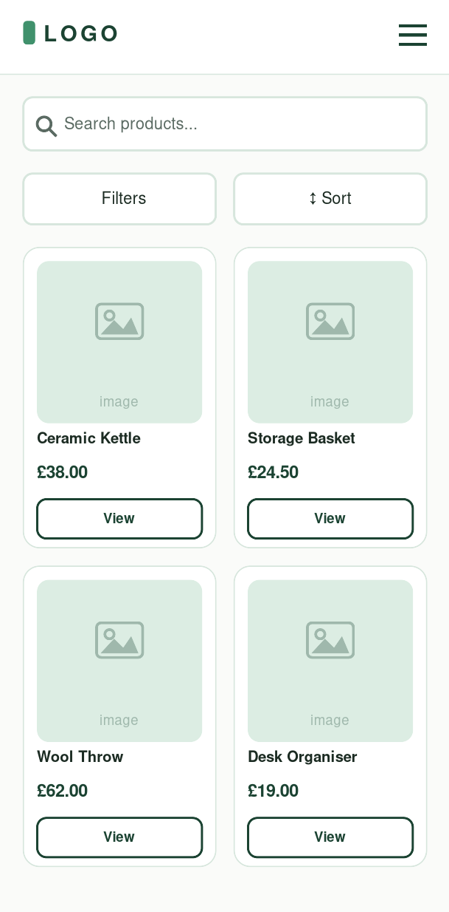
Figure 5.8 — Product Listing (Mobile)

5.9 Product Details — Mobile
The two-column desktop layout collapses to a single column, with the product image, metadata, description, and both call-to-action buttons stacked vertically in the same order as their desktop counterparts, so the information hierarchy stays identical across breakpoints.
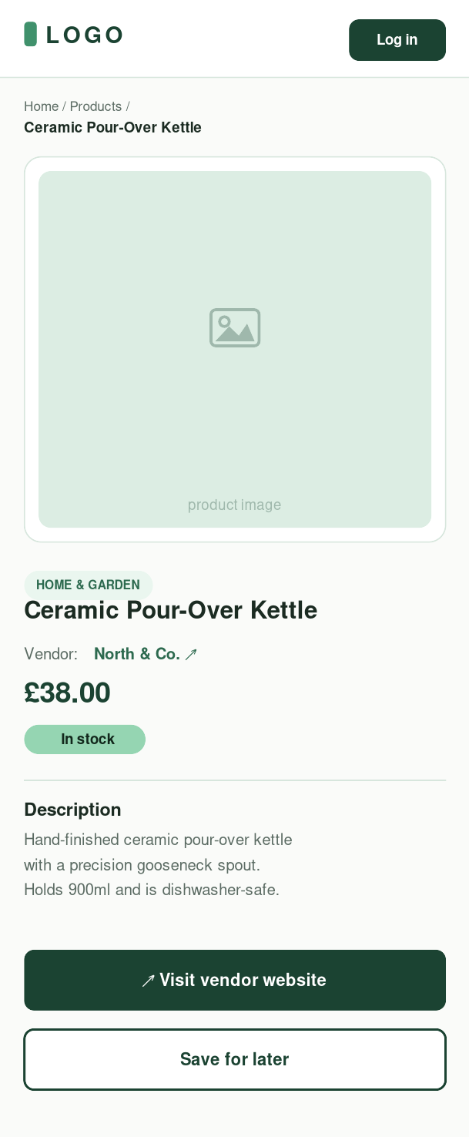
Figure 5.9 — Product Details (Mobile)

6. Accessibility and Responsiveness
All text and background colour combinations used across the mockups were checked against the WCAG 2.1 AA contrast thresholds (4.5:1 for normal text, 3:1 for large or bold text), in line with the brief's accessibility checklist (Section 3.4). One issue was identified and corrected during this process: white text on the original leaf-green secondary button fill produced a ratio of only 3.83:1, below the AA threshold for the button's text size. The secondary button fill was changed to the darker mid-green tone (#2D6A4F), raising the ratio to 6.39:1. The corrected results are summarised below.
Text / background combination | Ratio | WCAG AA
White text on Forest Green (nav, primary buttons) | 11.08:1 | Pass
White text on Mid Green (secondary buttons) | 6.39:1 | Pass
Forest text on Mint badge | 6.56:1 | Pass
Body text on page background | 14.30:1 | Pass
Muted text on white / pale mint | 5.08–5.63:1 | Pass
Price text (Forest Green) on white | 11.08:1 | Pass
Error red on white (validation only) | 6.46:1 | Pass

Font sizes were kept at 13px or above for all body and meta text, and at 15px or above for interactive labels, in line with the brief's requirement for readable font sizes. Responsive behaviour was prioritised for the platform's core discovery journey identified in the group's user journey map (Section 1.4): homepage, category or search entry, filtering, the product grid, and the product detail page were all produced at both desktop and mobile breakpoints, so that this journey can be demonstrated end-to-end on a phone-sized viewport during usability testing (Section 3.1).

7. Conclusion
The mockups presented in this document convert the group's low-fidelity wireframes into a single, consistent visual language — a mint and forest-green palette, a Poppins/Lato type system, and a shared set of card, button, badge, and form components — while remaining faithful to the pages, fields, and user journey already defined in the assessment brief and the team's earlier wireframes. These screens are intended to serve as the canonical visual reference for the Phase 2 React build, in particular for exact spacing, colour values, and the field-level layout of the admin product form.

